**Name**: Adwait S Purao  
**UID :** 2021300101  
**Batch :** B2

**Experiment No: 9**

**Aim:** To design and implement a circuit to check whether the number is even or odd and the parity of the number

**Software Required:** Trainer kit, IC 7486(XOR GATE), IC 7404(NOT GATE), Jumper wires

**Theory:**

*IC 7486(XOR GATE)*

The XOR gate can be designed with a transistor or with other gates but that will come up with a circuit large in size, to solve this issue we use **74LS86 IC**. The IC 7486 comes up with four internal XOR gates. The IC is smaller in size and it comes up with internal speed protection. It also comes in multiple packages that help to solve the requirement of IC in different devices. The output of the IC comes in TTL which makes it compatible to use with other TTL based devices and microcontrollers. The IC has wide use in designing of an adder at the logic level.

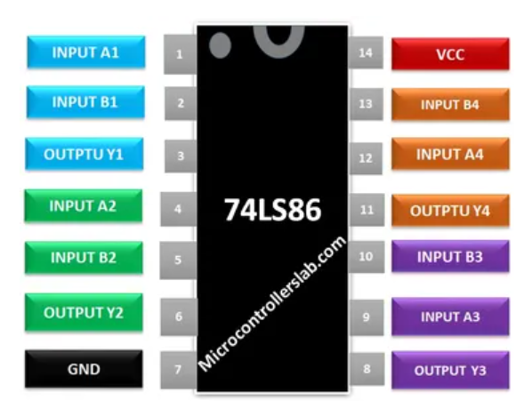

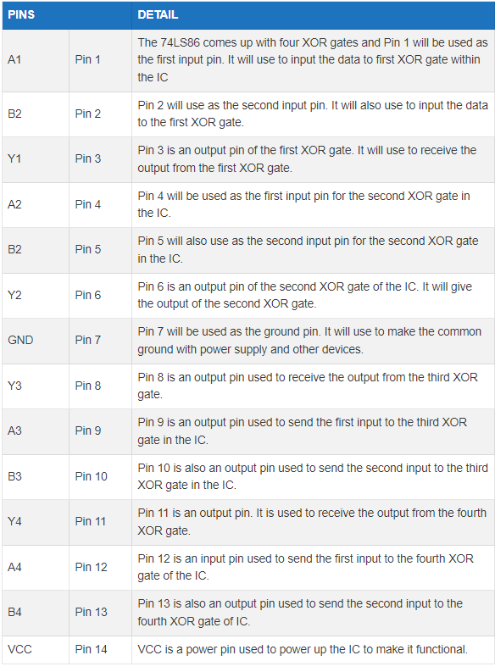

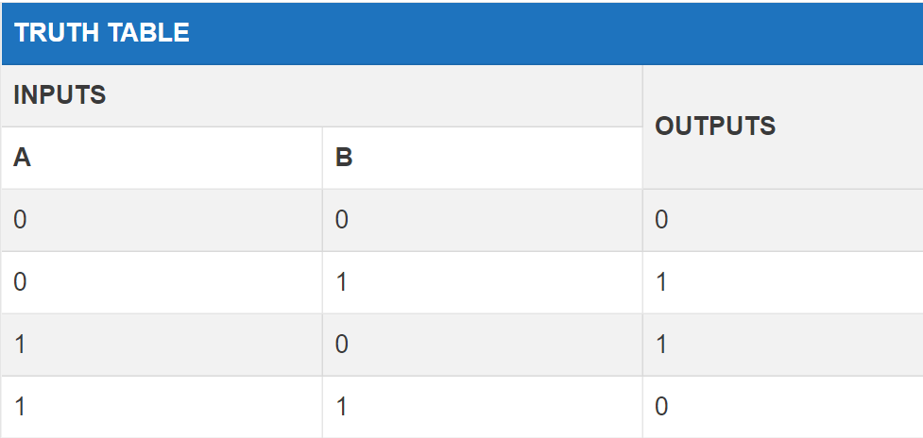

*IC 7404(NOT GATE)*

The NOT gate is the most basic logic gate of all other logic gates. NOT gate is also known as an **inverter** or an **inverting Buffer**. NOT gate only has one input and one output. When the input signal is "Low", the output signal is "High" and when the input signal is "High", the output is "Low"

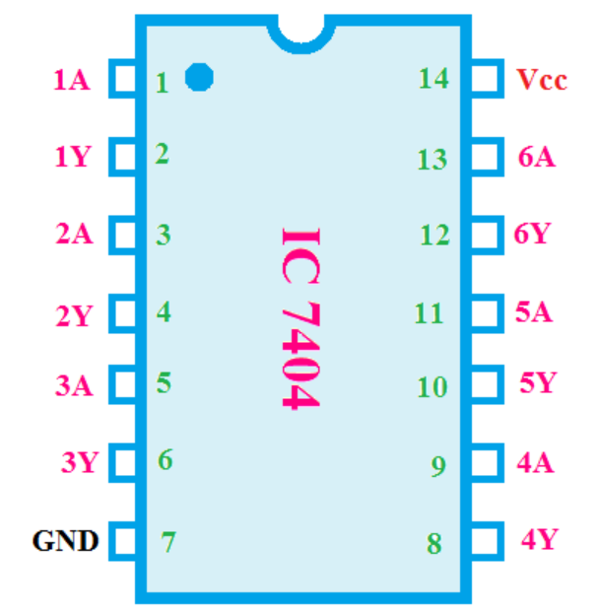

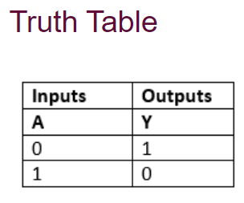

*Circuit to check whether the number is even or whether the number has an odd parity*

*Circuit diagram*

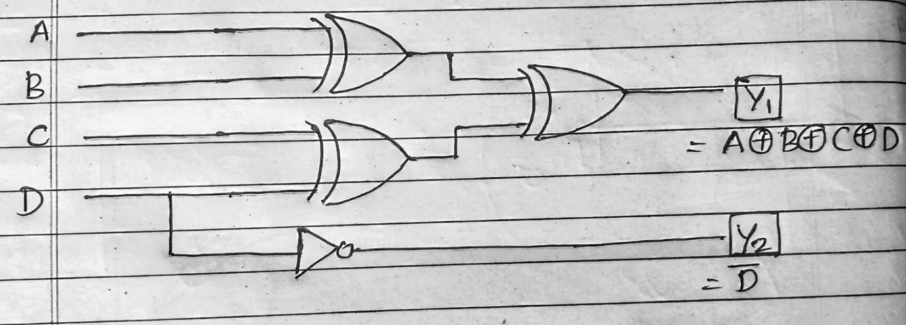

*Truth table*

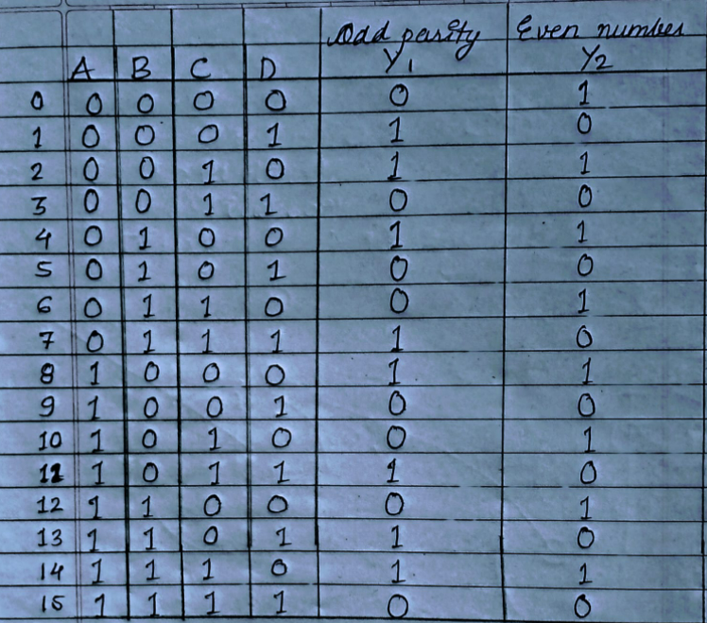

**Procedure:**

1. Prepare the truth table and with help of that prepare K-maps
2. With the help of K-maps design the logic circuit
3. On the PCB board put IC 7486 and IC 7404 in the respective sockets
4. Connect the wires as per the diagram
5. Toggle the inputs and verify the truth table

**Results and Observations:**

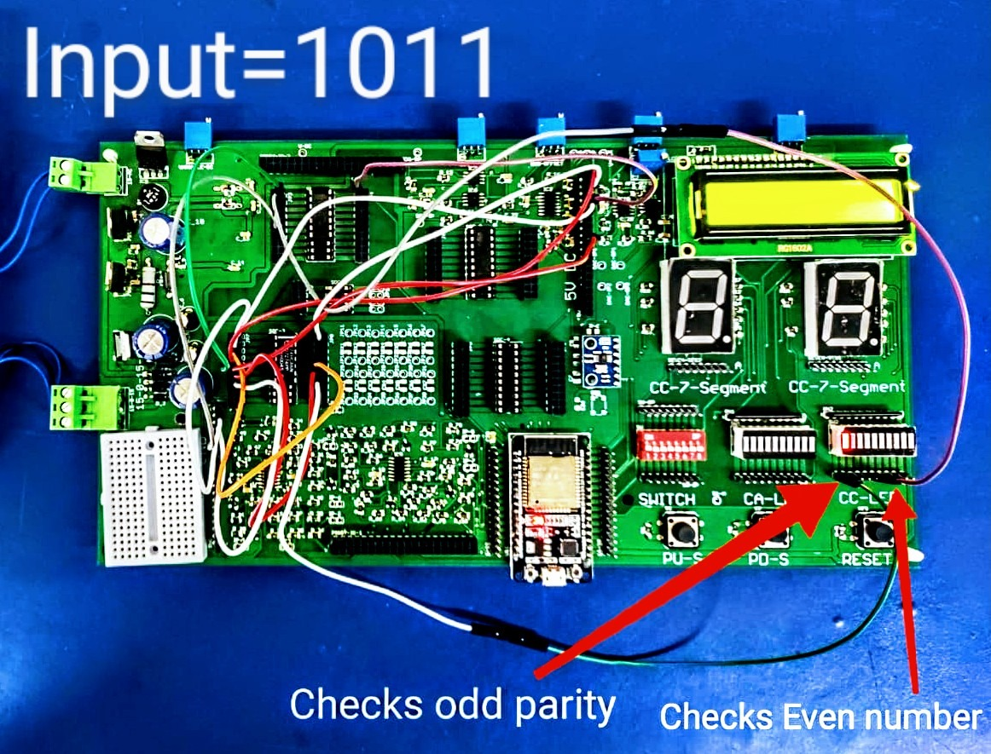

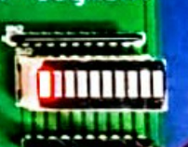

Checks whether number is even or odd

Odd parity

**Conclusion:**

